Exercise 8
IHW#5: Your firm – Analyze the statement of cash flows
aka – IHW: Your firm’s SCF

Due on ________________
Points possible ________________.

The purpose of this HW is to extend your understanding of (1) the contents and terminology of statements of cash flows and (2) the interpretation of the primary information on the statements of cash flows.

Requirements: Complete the following requirements:

Reading: Chapter 8 from Financial Reporting: First Take.

Analyze your firm’s statement of cash flows for the three years displayed on the statement. You may wish to use the following set of questions to guide your analysis, but you should feel free to use whatever approach you think is most informative.

General
  - How would you characterize the firm and its primary products in terms of a firm’s life cycle (Introductory, Growth, Mature, Decline)? NVIDIA has been incorporated since 1993. It could easily be considered a Mature company with years of financial success. NVIDIA is even the third largest US company by market cap. But given recent years and the drastic changes in technology their product has driven; NVIDIA may better be looked at as a Growth firm.
  - What amount of cash (and short-term securities) does your firm hold as a percentage of total assets and total revenue? Do you think your firm has the “optimal” amount of cash? What are the consequences of the firm having too much cash? Too little cash? - NVIDIA currently has 39% of their total assets in cash and short term investments or 42% of their total annual revenue.

Cash flows from operations
- What is the trend in net income?
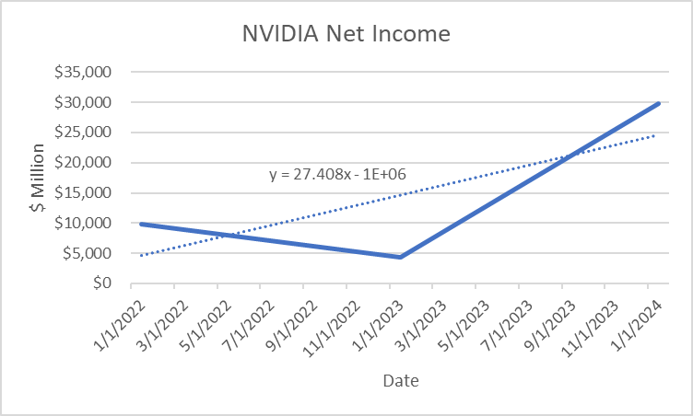
NVIDIA’s net income is trending upward with an average YoY increase of $27.4M The greatest increase comes from FY2024 which posted more than six times the Net income of the previous year.
- How have CFO amounts been changing over the three years? For each of the three years, was CFO greater than or less than net income? What contributed to the difference?
- What is the trend in net income relative to CFO? What reasons might explain this?

Cash flows from investing
- What has been happening to CFI over the three years? What reasons might explain this?
- Do capital expenditures exceed annual depreciation? What are the implications of this?
- Was CFO sufficient to pay for investments? If not, how were investments financed?

Cash flows from financing
- What is the trend in CFF?
- What is the trend in dividends?
- Were dividends paid from internal free cash flows? If external financing was used, can the dividend policy be sustained over time?
- What type of external financing does the firm rely on—equity, short term debt, long-term debt?

In general, do you think your firm does an adequate job of discussing its cash flow issues in the annual report? Explain.

